DESIGNING A LAN CONNECTION FOR A CAMPUS
DETAIL PROJECT REPORT

PRESENTED BY
KUMARI NISHA
BRANCH: I.T.
ROLL: 1411003D
YEAR: 3RD
SEMESTER: 5TH
INSTITUTE: B.I.T. SINDRI
DATE:18/12/2015
ACKNOWLEDGEMENT
To acknowledge here, all those who have been a helping hand in completing this project, shall be an endeavor in itself.
Nevertheless with all due regards and respect to the contributions made by various persons at each stage of the project, I take this as an opportunity to thank all those who have been instrumental in completion of my project ―“DESIGNING A LAN CONNECTION FOR A CAMPUS ”
I thank Mr. ABHAY KUJUR, HEAD OF DEPARTMENT OF C.S.E BRANCH, for giving me the opportunity to do this Project. I feel deep sense of gratitude towards Mr. SUJIT KUMAR , Digital Computers, CCNA, CCNP Certified for helping me in this project and being a constant source of motivation and guidance throughout the course of my project. I also extend my thanks to all the faculties and my batch mates in Information technology department, for their support and guidance throughout the course of my project.

Thank you all for being there for me always.

KUMARI NISHA

ABSTRACT

The objective of this project is to design a LAN connecting four departments in a campus layout. Two designs meeting specific requirements are discussed in this report, one using thin coax and the other using UTP. Arguments justifying the design and correctness, together with the total implementation costs are presented for each implementation. Fiber optic cable is used in the network backbone because it offers high data rate capacity, no electrical interference, ability to withstand severe weather conditions and larger maximum segment length.

DECLARATION

I, KUMARI NISHA, Roll No 1411003D, student of INFORMATION TECHNOLOGY (2014-17), 5TH SEMESTER at B.I.T. SINDRI ,hereby declare that the DETAILED PROJECT REPORT entitled “DESIGNING A LAN CONNECTION FOR A CAMPUS ” is an original work and the same has not been submitted to any other Institute for the award of any other degree.

ACKNOWLEDGEMENT
To acknowledge here, all those who have been a helping hand in completing this project, shall be an endeavor in itself.
Nevertheless with all due regards and respect to the contributions made by various persons at each stage of the project, I take this as an opportunity to thank all those who have been instrumental in completion of my project ―“DESIGNING A LAN CONNECTION FOR A CAMPUS ”
I thank Mr. ABHAY KUJUR, HEAD OF DEPARTMENT OF C.S.E BRANCH, for giving me the opportunity to do this Project. I feel deep sense of gratitude towards Mr. SUJIT KUMAR , Digital Computers, CCNA, CCNP Certified for helping me in this project and being a constant source of motivation and guidance throughout the course of my project. I also extend my thanks to all the faculties and my batch mates in Information technology department, for their support and guidance throughout the course of my project.

Thank you all for being there for me always.

KUMARI NISHA

State of Information Technology

It has been observed by the IT Task Force that the approach of the various distribution utilities towards IT has been piecemeal with standalone applications deployed for a limited operational requirement. In other words, IT has been used as a tool to address a specific issue or two at a time and not as a long-term, holistic strategy. While Indian IT sector has helped numerous organizations around the globe derive substantial benefits from application of IT, there is plenty of room for IT application within the Industrial sector in India. There is a need to look at the global practices in IT adoption in the educational sector from the point of networking so that India can benefit from it. The IT task force is of the view that the gap in IT adoption globally and in the Indian Industrial sector is apparent and glaring and even the rate of overall technology adoption in India is on the lower side. Globally IT is also being used to enable operations at a transaction level thus providing advantages like in-built process controls, workflow enabled transactions, single point of data capture and support for timely strategic decision making. On the other hand, in India, the core operations are still manual, paper work is more in use and therefore face issues like ad-hoc decision making, poor data quality, long decision making cycles and underutilization of IT investments. In order to reap the benefits of IT, the wide gap between India and global best has to be bridged.

Introduction
Computer networks are essential for day-to-day communication, e-commerce transactions, information sharing and the like. Networks can be broadly categorized according to their size, which helps determine their scope and intended application. Different networks are implemented in different ways. Local Area Network (LAN) is a high speed computer network used for connecting computers and sharing resources over a relatively small area (few kilometers). Typically, LAN can be implemented in an area as small as a dorm room to one that is as large as a university campus [1]. In this project, we will design a wired LAN for one such campus layout. We will use two different cabling technologies and topologies for our wired LAN. The first Ethernet design will be implemented using thin coax cable on a bus topology in which all devices will be connected to the central bus. The second design featuring the UTP cable will be implemented using star topology in which all devices will communicate on the network by passing data through a hub.

What is a Local Area Network?

A LAN comprises the linking of two or more computers within a single site for the purpose of sharing data, software and peripherals such as printers. Within a school, a LAN can vary in size from a few workstations in a room to a complete school network covering several buildings. To add computers to a network, each will require a Network Interface Card (NIC). Various forms of network cabling are available to link the computers. Some of these forms are discussed later in this section. Wireless links are also possible where physical cabling is either difficult or very expensive. Different types of server devices can be added providing centralised access for file, application, printer, CD ROM and other services.

Benefits of a Local Area Network

A local area network can provide solutions for a range of problems:

• Once established, workstations can be a simple, inexpensive option with only network boot software required on each workstation.

• Applications installed on the file server can be made available to any workstation and each application needs only be installed once. Users can easily share the same program files.

• Almost any peripheral device (printers / scanners / modems / fax cards etc.) can be networked and shared by any workstation. This minimises the number of peripheral devices required.

• Promotes collaborative work through the easy sharing of files.
- Electronic mail (E-mail) becomes a valuable communications tool,reducing the amount of paper messages being forwarded around the school.

• Individual users can be allocated levels of security depending on their areas of responsibility.
• Backup of data is more likely to occur than with standalone computers.

• Virus attacks can be managed more effectively using anti- virus software.

• All servers can be administered from a single location.

• Servers can be secured in a strong-room, making theft of
workstations less of a likelihood.

• Software license compliance is more easily managed on a LAN. eg. Software tracking software. (Software license control can become an issue when the number of workstations on the network exceeds the number of licenses for any particular application. Industries must ensure there are sufficient licenses for each application to cover the number of concurrent users of each product.)

Issues with a Local Area Network

• Cabling some sites can be difficult and expensive particularly where large distances are involved between buildings or within heritage buildings.

• As the system grows, there will be a need for a trained System Administrator or maintenance contract.

• When the stage is reached where the school relies on the network for its resources, a backup and disaster recovery (contingency) plan is needed.

• If the LAN covers the whole school, input into the planning and development of the LAN becomes a decision for the whole school community. This reinforces the need for a school technology committee and the development of a technology plan.

Types of Local Area Networks

Server-Based LANs
• This normally uses a dedicated file server which contains the
Network Operating System as well as software and data to be shared.
• The workstations on the LAN utilize the programs and data from the server.
• These LANs can be very reliable and responsive and can cater for hundreds of workstations.
Peer-to-Peer LANs
• The network operating system (NOS) software is installed on all workstations.
• Because workstations are behaving both as workstations and servers, this type of network can be slow and restrictive. For example, if someone is word processing on the computer with the printer attached and another user sends a large print job, the word processor may suspend operation for a period until the print job is complete, causing inconvenience.
• The built-in networking on Apple Macintosh computers and in
Windows 95 and Windows for Workgroups are forms of peer-to-peer networking.
• As peer-to-peer networking is now provided as standard with most modern computers, the only additional cost is cabling and
connectivity. But this form of networking is typically only suitable for small workgroups of up to six or so computers.
(It should be noted that most server-based network operating systems can co-exist with peer-to-peer on the same server network, providing the advantages that each offer.)

.
  - Ethernet Cables

Unshielded Twisted Pair (UTP) cable consists of eight insulated copper wires grouped together to form four pairs. The wires in each pair are twisted around each other to reduce signal degradation from interference. The number of twists per meter for each pair can be varied to further reduce crosstalk noise. The Category 5 UTP (also 100BaseT) used for fast Ethernet, supports data rates of 100 Mbps or higher and has a maximum segment length of 100-meters. The standard connector for UTP is an RJ-45 connector. By far, UTP is the most popular and generally the best option for wired LANs. Thin Coax cable consists of an insulated copper wire surrounded by a woven copper braid to reduce the amount of outside interference. An outer jacket covers the two conducting elements. Coax cable supports data rates from 10 to 100 Mbps and can be laid over greater distances than UTP with fewer repeaters. The thinnest cable used for Ethernet has a maximum segment length of 185-meters. Network interface cards (NIC) with the standard connector for coax cables, the British Naval Connector (BNC), are a rare find nowadays.

FIGURE 1.1: ETHERNET CABLES

(a) UTP Cable and RJ-45 Connector

(b) Coax Cable and BNC Connector

(c) Fiber Optic Cable and SC Connector

Fiber Optic cable consists of a center glass core surrounded by layers of protective plastic shield, followed by a very strong plastic Kevlar (used in making armor) and an outer jacket. The electrical interference is absent in fiber optics since it transmits light and not electrical signals. 100BaseF is the fiber optic specification used for carrying Ethernet signals. It supports data rates up to 10 Gbps and has a maximum segment length of 2000- meters. The most common connector for 100BaseF is the SC connector, which has two optical connections, one each for connecting to transmit and receive. The exceptional qualities of 100BaseF such as high data rate capacity, no electrical interference, ability to withstand severe weather conditions and larger maximum segment length, makes it an ideal choice for connecting networks between buildings. Figure 1.1 illustrates all the three types of Ethernet cables discussed in this section.

Repeater
A repeater is a Physical Layer (layer 1) analog device that connects two cable segments. It operates on bits on the cable segments, amplifying their signal strength before sending it to the other segments. Classic Ethernet allowed four repeaters to join five segments together. The concept is still in use, mainly for reliable data transfer.

Hub
A hub is also a Physical Layer (layer 1) device and somewhat similar to the repeater; it operates on bits and the number of hubs is limited to four for a joining segments together. It is mainly used for UTP networks to provide connection between nodes. A hub does not isolate traffic because two signals arriving at the same time on a hub will collide and will have to be retransmitted. Hubs form a single collision domain.

Bridge
A bridge is a Data Link Layer (layer 2) device and unlike repeaters and hubs, it operates on frames of data. Bridges use look-up tables to route the data frames to the destination address after reading it from the frame header. Unlike hubs, bridges manage traffic to avoid collisions.

FIGURE 2.2: CAMPUS LAYOUT

Design

In this section, we will discuss the thinnest and UTP LAN implementations for the campus layout shown in Figure 2.2. The cost listing of the available equipment for our design is depicted in Table 2. The backbone consists of a 6-port fiber repeater with four 2-port bridges. We will be using the same network backbone for both designs. The only change would be using Fiber/Coax 2-port bridges for thin coax implementation as opposed to using Fiber/UTP 2-port bridges for UTP implementation. It should be noted that all repeaters and bridges are placed in wiring closets (WC). WC1 of Marketing and WC3 of Engineering departments house their file server and 2- port bridge, WC1 of Support contains their file server, 2-port bridge and 8-port repeater.
Similarly WC2 of manufacturing is home to their three file servers, two 8-port repeaters, a 2-port bridge and the 6-port fiber optic backbone repeater.

Thin Coax Implementation & Justification

Our implementation for the campus layout using thin coax is shown in Figure 2.3. The hosts are connected on a bus topology with the thin coax connected via the T-connector in a daisy-chain fashion. All hosts numbered 15, 30, 24, 48 and 72 in Figure 2.3 are terminated with a 50 BNC terminator. We have already discussed the benefits of fiber optic cable in Section 1.1. A fiber optic cable repeater is used as a backbone for the thin coax network. The backbone is used to provide network reliability and to make it robust. Four 2-port Fiber/Coax bridges are used to connect each department to the network. The total length of required fiber cable is 200 + 80 + 130 + 40 (probable routing overhead) = 450 meters.
Each file server supports a maximum of 30 users and they are not be shared through departments. Therefore, one each is given to Engineering, Marketing and Support for their 15, 15 and 30 users respectively while Manufacturing gets three file servers for their 72 users.
One segment of coaxial cable is needed for Marketing and Engineering departments, two are needed for Support while three are in use for Manufacturing. This is because it is not advisable to have more than 30 connections on a single coax length. The total length of required coax cable is 185 + 185 + 370 + 555 + 55 (overhead) = 1350 meters.
In order to connect all the hosts and the file server on the network, the number of required NIC/coax ports is # Hosts (15 + 15 + 30 + 72) + #Servers (6) = 138.

BASIC LINK DIAGRAM FOR DATA PORTS

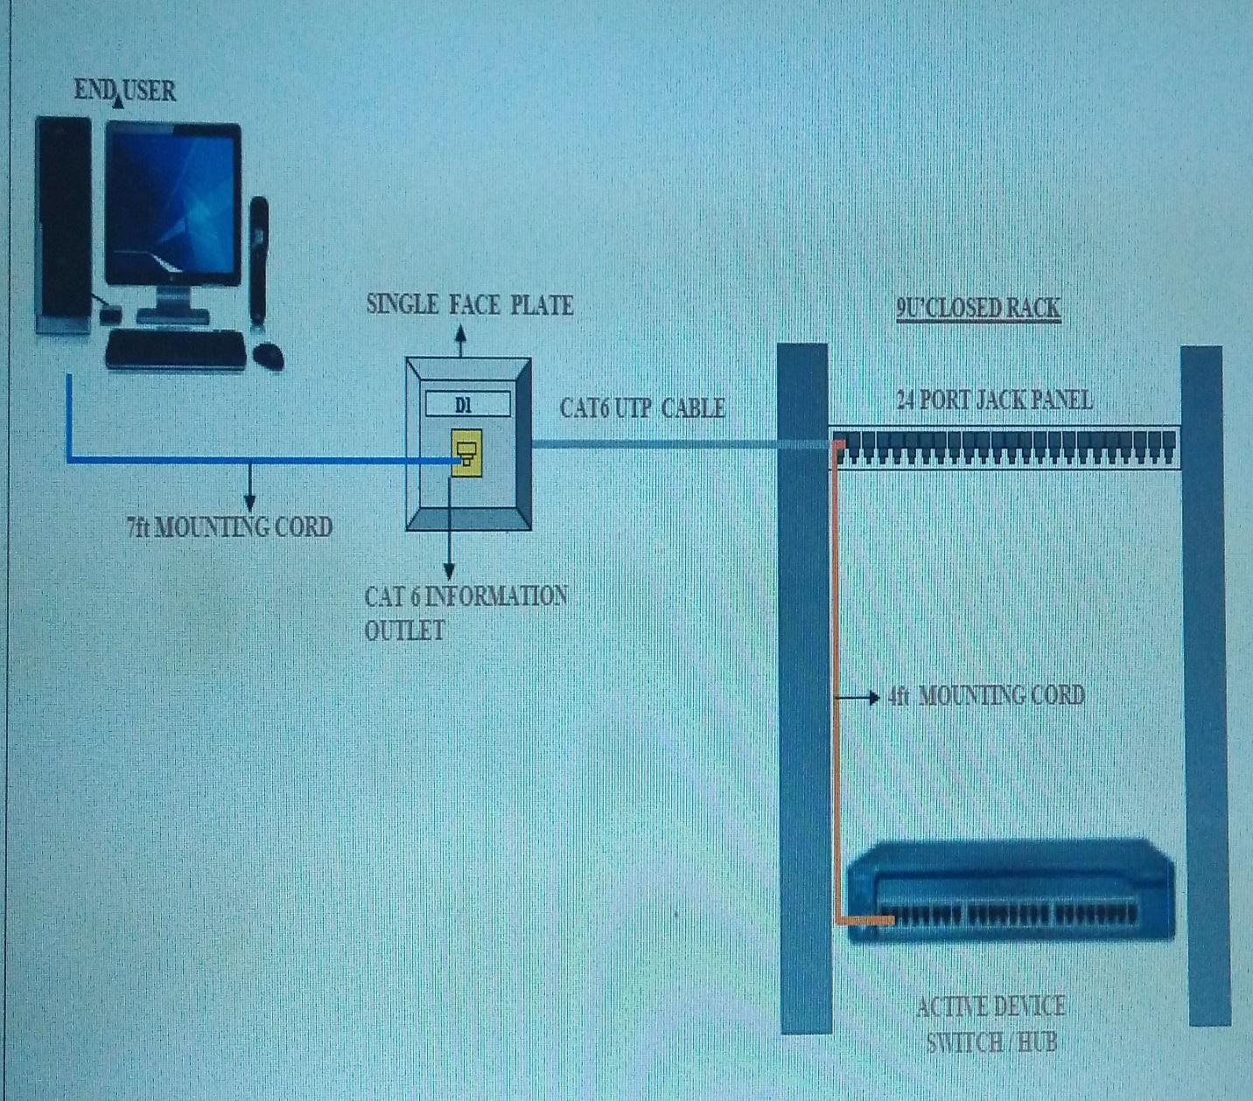

SERVER ROOM RACK-SR

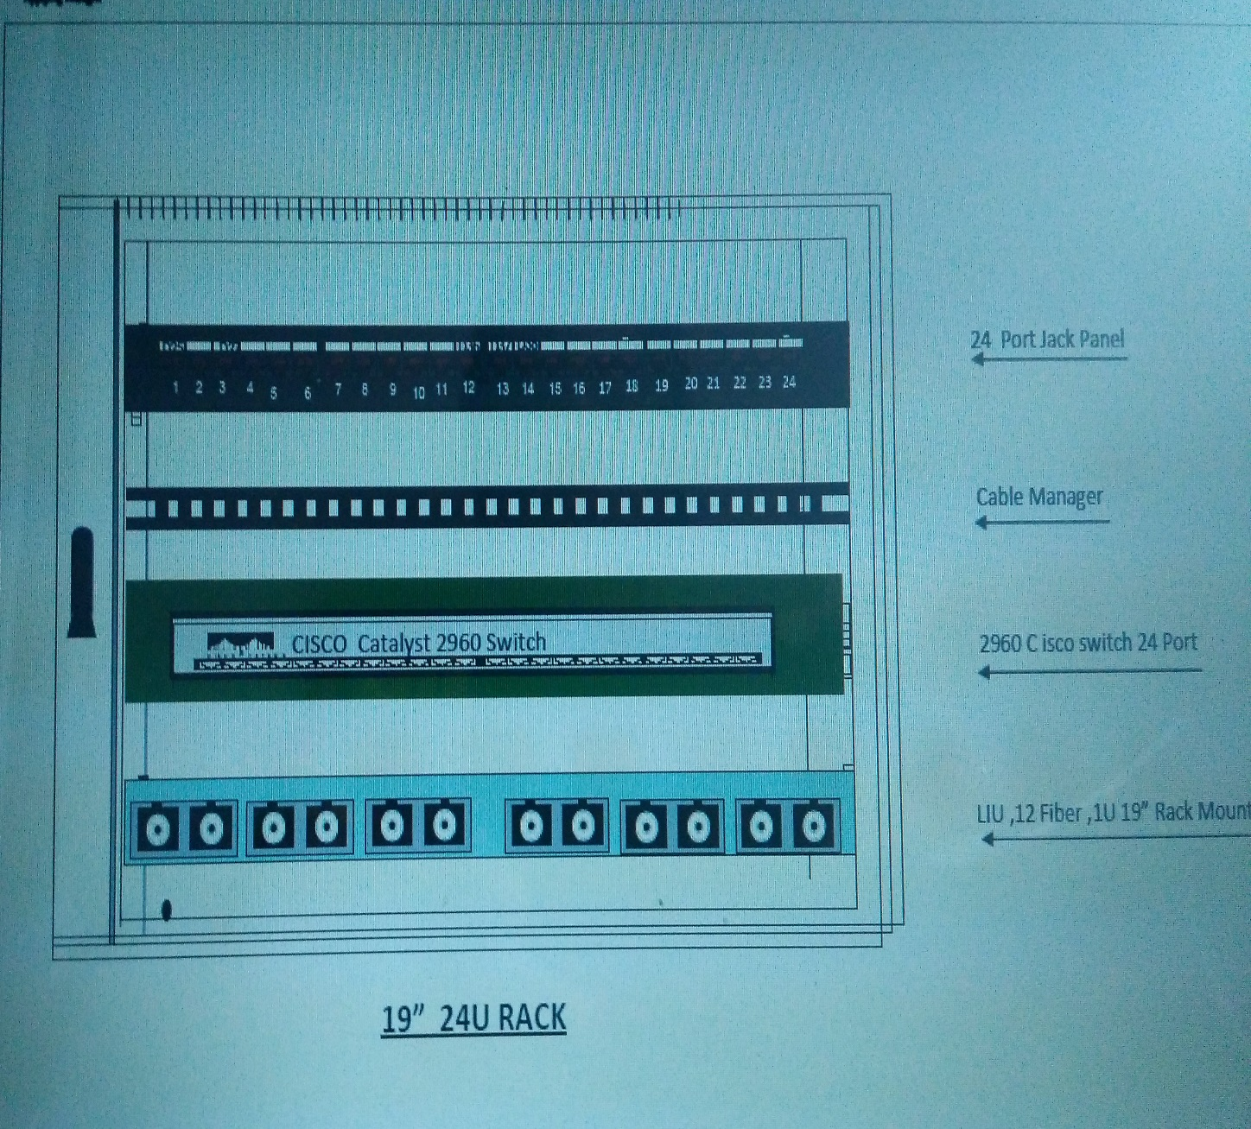

Figure 2.3: Thin Coax LAN Implementation

EQUIPMENT | UNIT | COST($)
Thin coax | 1350 | 1350
Fiber optic cable | 450 | 900
NIC/Thin coax ports | 138 | 9660
Multiport coax repeater | 2 | 3000
Multiport fiber repeater | 1 | 2000
2-port Fiber/Coax Bridge | 4 | 8800
Pentium File Server | 6 | 54000
TOTAL |  | 79710

2.1.1 Thin Coax Implementation Cost

UTP Implementation & Justification

A fiber optic cable repeater is again used here as a backbone for the UTP network. Four 2-port Fiber/UTP bridges are used to connect each department to the network. The total length of required fiber cable is 200 + 80 + 130 + 40 (probable routing overhead) = 450 meters.

Each file server supports a maximum of 30 users and they are not be shared through departments. Therefore, one each is given to Engineering, Marketing and Support for their 15, 15 and 30 users respectively while Manufacturing gets three file servers for their 72 users.
Since UTP uses star topology (all hosts and servers connected to their respective hubs) we need one 36-port hub each for Engineering, Support and Marketing departments. For Manufacturing department however, we will need three 36-port hubs (72 hosts + 1 server). Then there hubs in manufacturing will be connected in daisy chain fashion (similar to the thin coax network connection).
The estimate of the total length of UTP cable required for cabling is rather tricky. From the department floorplan we can see that Marketing and Support departments are 50-m wide. Assume that 1/5 of the hosts of both lie within 10-m the next 1/5 at 20-m and so on.
The floorplan of Manufacturing department shows that it is 100-m wide. Assume that 1/18 of hosts lie at 4-m intervals. Similarly for Engineering, assume that 1/5 of hosts are placed at 8-m intervals. Then the total UTP cable length comes to 450 + 900 + 3240 + 300 =4890.
In order to connect all the hosts and the file server to the hubs on the network, the number of required NIC/UTP ports 138.

Figure 2.4: UTP LAN Implementation

EQUIPMENT | UNIT | COST($)
UTP Cable | 4890 | 4890
Fiber optic cable pair | 450 | 900
NIC/UTP ports | 138 | 9660
48 port UTP hub | 6 | 24000
Multiport fiber repeater | 1 | 2000
2-port Fiber/UTP Bridge | 4 | 8800
Pentium File Server | 6 | 54000
TOTAL |  | 104250

2.2.1 UTP Implementation Cost

TOTAL COST ESTIMATION
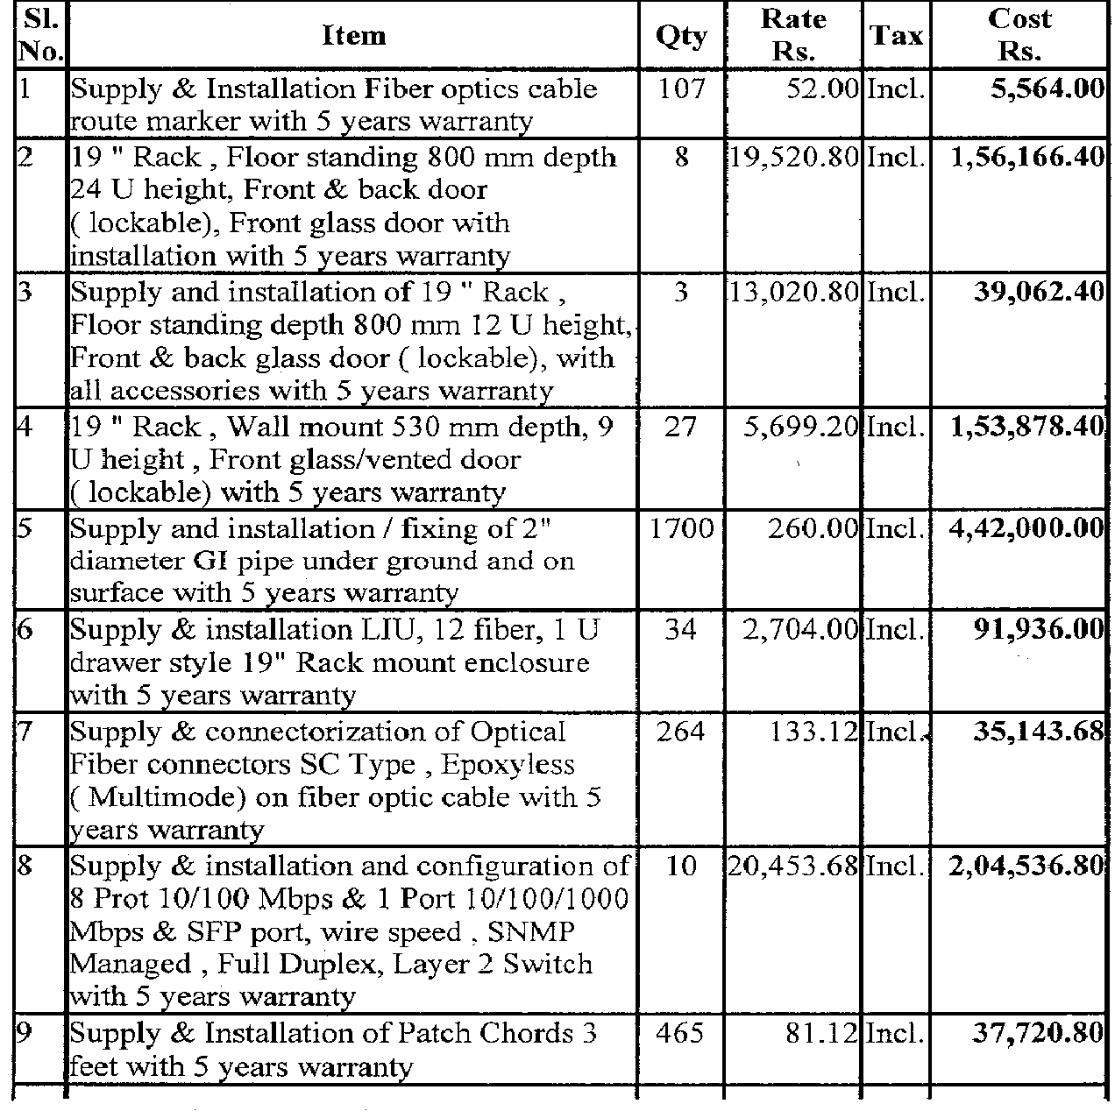

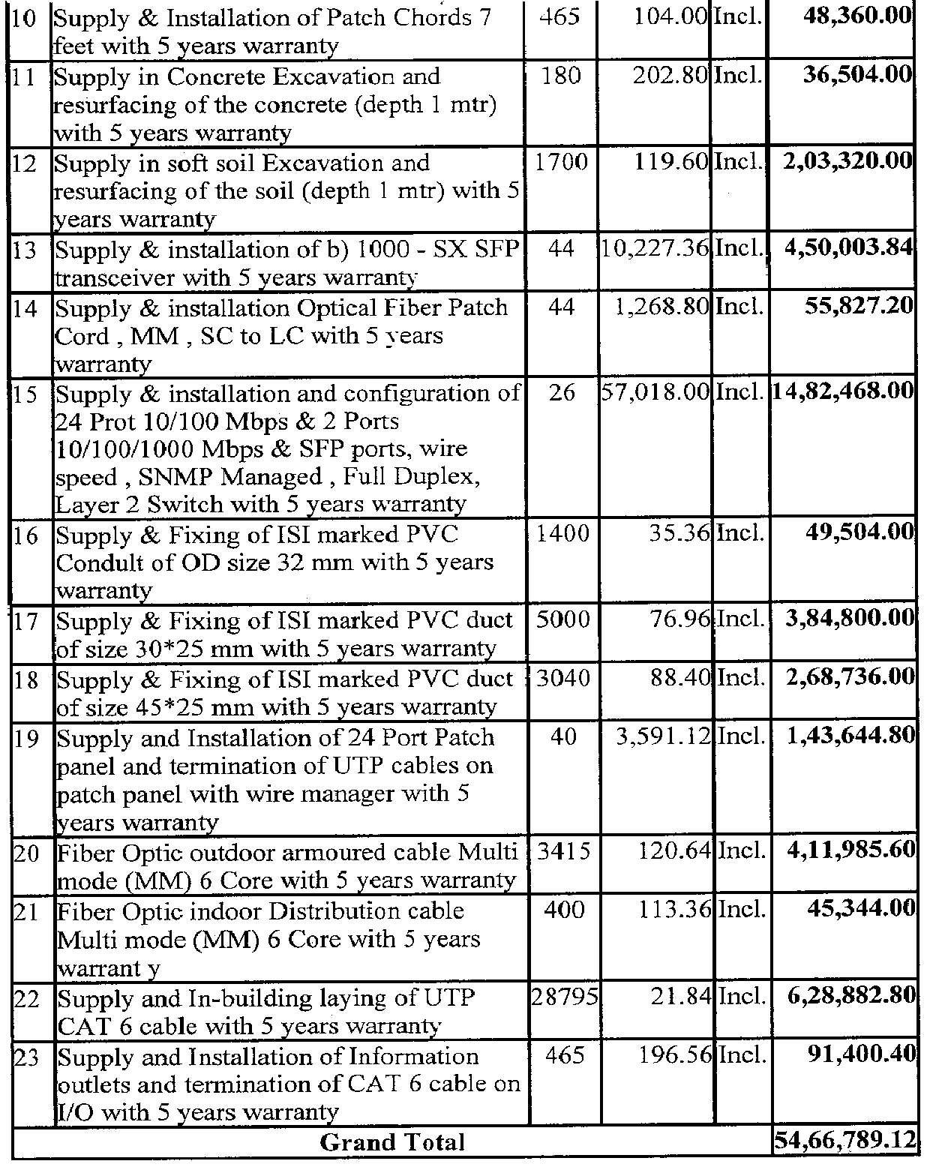

Summary

We implemented a LAN for campus layout using two different cabling techniques and compared the cost of one to the other. Turns out that UTP network is more expensive to implement than thin coax (by about $25000). This however is a small price to pay for stable more reliable network. In case of thin coax, if a cable segment of any daisy chain connected host is damaged then the entire department’s network will be lost. This problem does not arise in UTP because each host has a dedicated connection with the hub. In addition to that users on UTP-based LAN will also get more bandwidth and thus higher performance than thin coax. We used fiber optic in the network backbone due to its ability to transmit Ethernet signals to farther distances than either UTP or coax, without the use of signal boosters and repeaters. Furthermore, we are guaranteed zero interference because of fiber.

CONCLUSION
This is detail project report on designing a lan connection for any industry or company where we have to provide lan connection in the engineering, manufacturing, marketing, and support departments. We have studied the merits and demerits of using thin coax cable and utp cable for the implementation of lan here. Thus, after the clear study I conclude and prefer the use of UTP cable because of its better performance.
I gained a good deal of knowledge through this project and it has also enhanced my knowledge regarding networking. Altogether it was an interesting experience throughout the project.
Thank you….

References

[1] Andrew S. Tanenbaum, Computer Networks, Fourth Edition, Prentice Hall PTR.

[2] Stephen McQuerry, CCNA Self-Study: Introduction to Cisco Networking Technologies,Cisco Press.

